Project Design Phase
Problem – Solution Fit Template
Date | 18 February 2026
Team ID | LTVIP2026TMIDS24197
Project Name | Civil Engineering Insight Studio
Maximum Marks | 2 Marks

Customer Segment
Segment | Description
Customers | People who need help regarding products/services
Agents | Support staff handling customer queries
Admin | Manages agents, monitors system activity

Customer Problems

Core Problems (Customer Side)
Problem ID | Problem Description | Type
P1 | Customers don’t know whom to contact for support | Frequent
P2 | Delayed response from support team | Urgent
P3 | No proper tracking of complaint status | Frustrating
P4 | Repeating the same issue multiple times | Annoying
P5 | No transparency in issue resolution | Trust issue

Existing Behavior (Current Situation)
Customer
↓
Calls / Emails randomly
↓
No proper tracking
↓
Waits for response
↓
Gets frustrated
Customers currently:
- Call support numbers
- Send emails
- Message through social media
- Wait without tracking status

Emotional Impact
Problem | Customer Feeling
No response | Ignored
Delay | Frustrated
No tracking | Confused
Repeating issue | Annoyed
No transparency | Lack of trust

Proposed Solution (CSS)

Core Solution
A role-based web application where:
- Customers can register and submit issues
- Agents can manage assigned users
- Admin can manage agents and assign customers

Solution Features Mapping
Problem | Solution Feature | Fit Explanation
No contact clarity | Online complaint submission | Clear channel
Delayed response | Agent assignment system | Faster response
No tracking | Status tracking dashboard | Transparency
Repeating issue | Centralized issue history | One-time explanation
No transparency | Admin monitoring | Trust building

Functional Fit Diagram
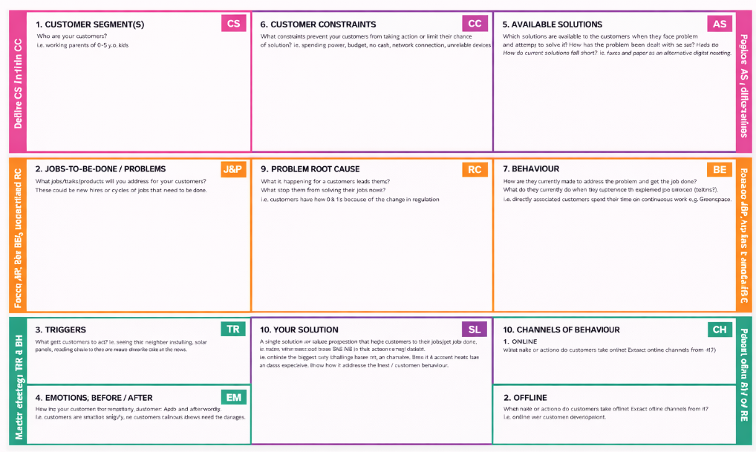

Behavioral Fit
Instead of:
- Calling randomly
- Sending emails
Customers now:
- Log in
- Raise complaint
- Track progress
- Get notification
This matches modern digital behavior (web/app usage).

Value Proposition
For Customer | For Agent | For Admin
Easy complaint submission | Organized workflow | Full system control
Status tracking | Assigned users only | Agent management
Faster resolution | Clear responsibilities | Performance monitoring

